NAME: A .GOPI RAJ
REG NO: 1924124543

Experiment: 8
Steering Angle Variation in MIMO Beamforming Using MATLAB
Aim
To analyze the effect of steering angle variation in a MIMO beamforming system by studying steering angle, array gain, and beam direction error using MATLAB.
Objectives
1. To analyze the steering angle of a MIMO beamforming system by directing the beam towards different target directions using MATLAB.
2. To compare the array gain achieved for different steering angles in a MIMO beamforming system using MATLAB.
3. To evaluate the beam direction error between the desired steering angle and the actual beam direction using MATLAB.
MATLAB Code:
clc;
clear;
close all;
angle = [-60 -30 0 30 60]; % Steering Angles (degrees)
gain = ones(size(angle)); % Normalized Gain
figure
polarplot(deg2rad(angle), gain,'o-','LineWidth',2)
title('Steering Angle Variation in MIMO Beamforming')
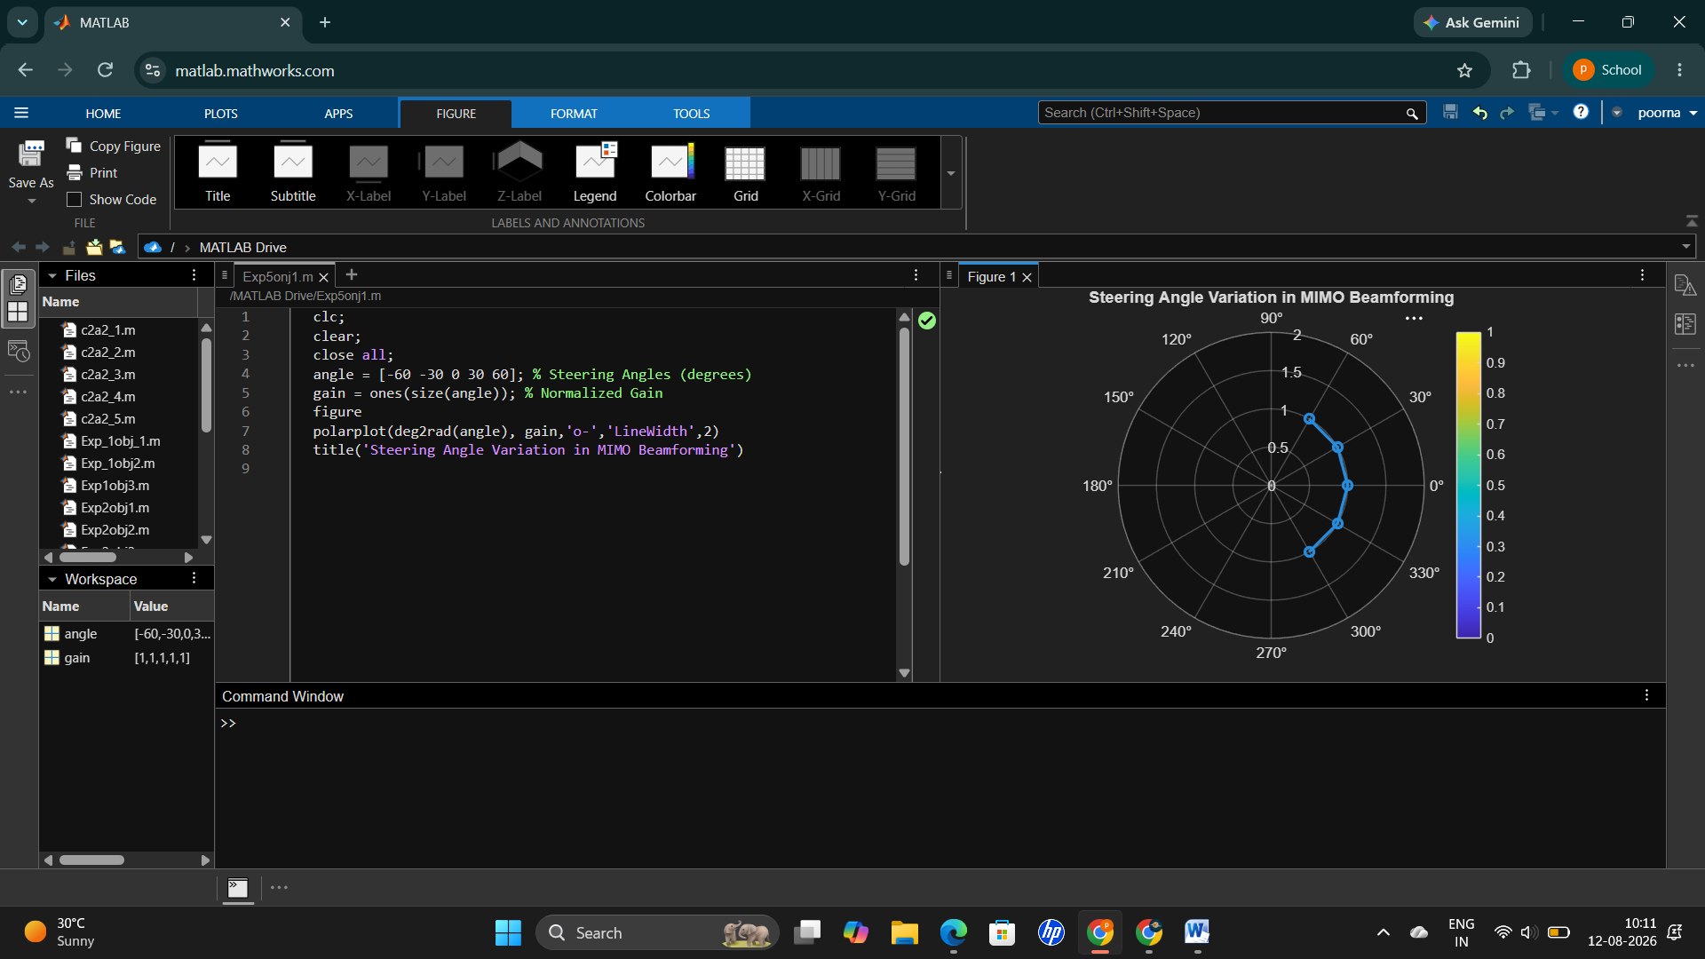

Objective – 2
Compare Array Gain (dB)
Compare the array gain obtained at different steering angles using MATLAB. Observe the improvement in signal strength achieved through beamforming.
MATLAB Code:
clc;
clear;
close all;
angle = [-60 -30 0 30 60]; % Steering Angles (degrees)
gain = [9 12 15 12 9]; % Array Gain (dB)
figure
bar(angle, gain)
grid on
xlabel('Steering Angle (Degrees)')
ylabel('Array Gain (dB)')
title('Array Gain for Different Steering Angles')
Expected Output
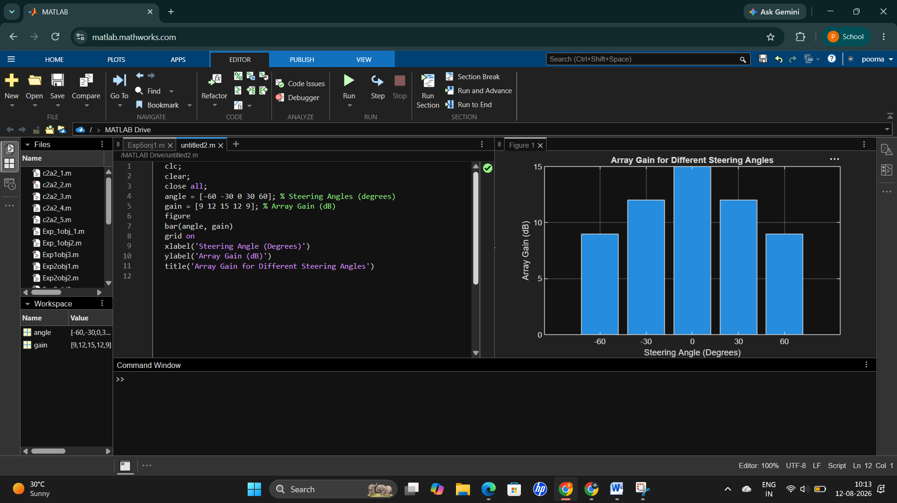 Objective – 3
Evaluate Beam Direction Error (Degrees)
Analyze the difference between the desired steering angle and the measured beam direction using MATLAB. Compare the beam direction error for various steering angles and evaluate the beam steering accuracy.
MATLAB Code:
clc;
clear;
close all;

% Desired and Actual Steering Angles (degrees)
desired = [-60 -30 0 30 60];
actual = [-58 -32 1 29 62];

% Beam Direction Error
error = abs(desired - actual);

% Plot
figure;
plot(desired, error, 'o-', 'LineWidth', 2);

grid on;
xlabel('Desired Steering Angle (Degrees)');
ylabel('Beam Direction Error (Degrees)');
title('Beam Direction Error for Different Steering Angles');
Expected Output
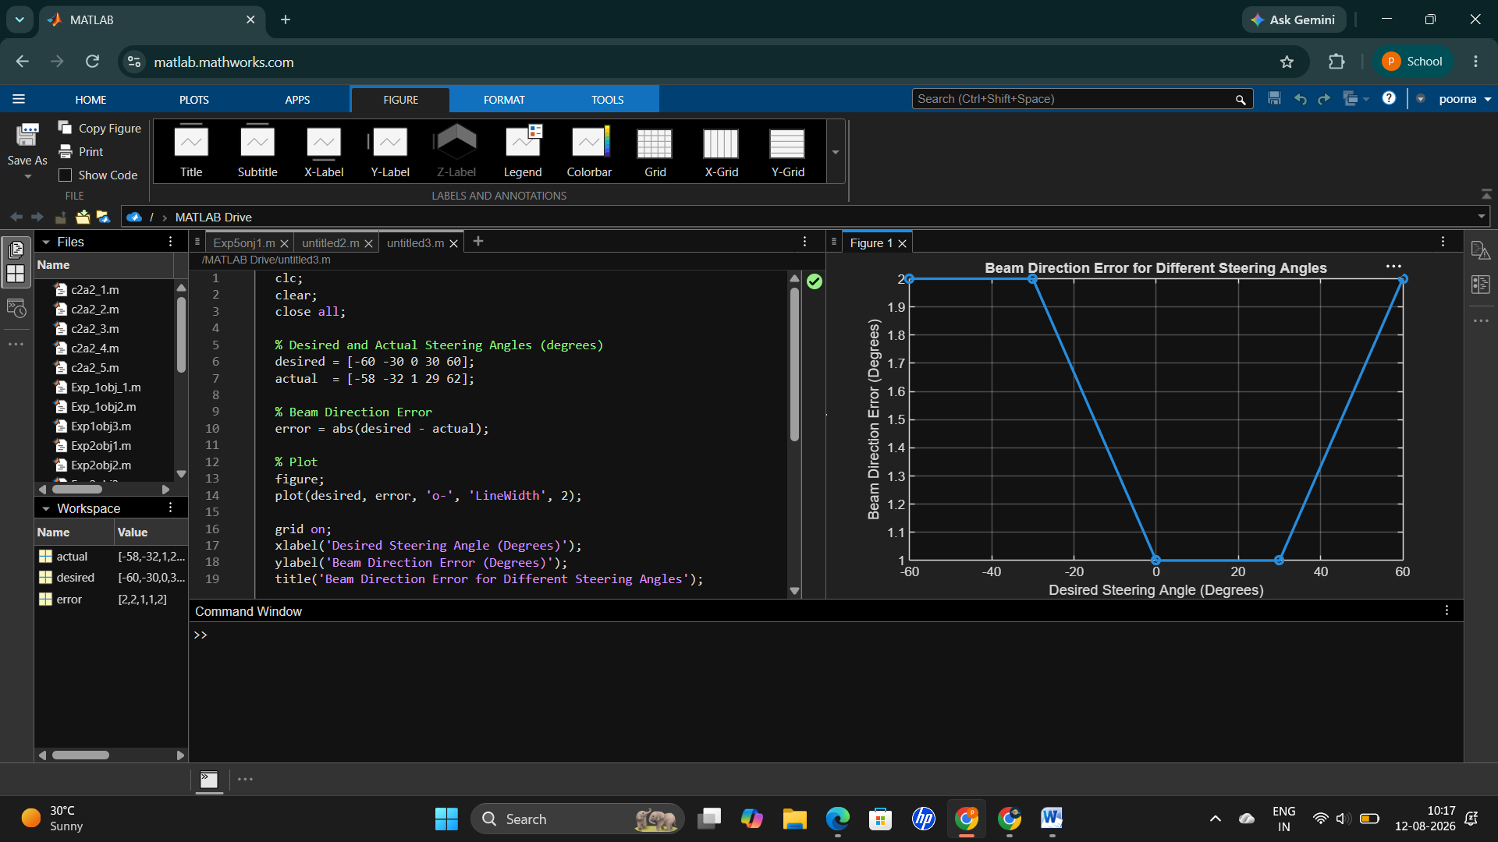

Result
The MATLAB analysis successfully demonstrated steering angle variation in a MIMO beamforming system. The results showed that beam steering effectively directs the transmitted energy toward different angles, while maintaining high array gain and minimizing beam direction error

